Hourly Load Profile Generator For Mexico

Mehul Raheja

# Introduction

The goal of this project was to observe the effect policies would have on the electricity load curve for each SWITCH region in Mexico. The methodology was to disaggregate the hourly load curve into the different sectors of usage and use that data to see how policies targeting a type of customer would affect an entire region load curve. With the paucity of data, broad assumptions (Appendix A) were made to allow the application of state data to inter-state electricity providers and the correlation of US based hourly load data to that of Mexico. Nevertheless, with the scope of the project being to model policies rather than generate a precise load curve, the assumptions do not detract from the goal.

# Generating the Load Curve

The complete code for this can be found under the Load Profile Generator Notebook in the “Final Product” directory.

The key assumption used in generating the hourly load curve for each region was that the monthly load curve between regions will vary, however the spread of the hourly load curve within each month will not. For example, the aggregated monthly large industrial load for Obregon and Laguna in January can differ but the usage through the first hour is assumed to always be 0.1037% of the total load.

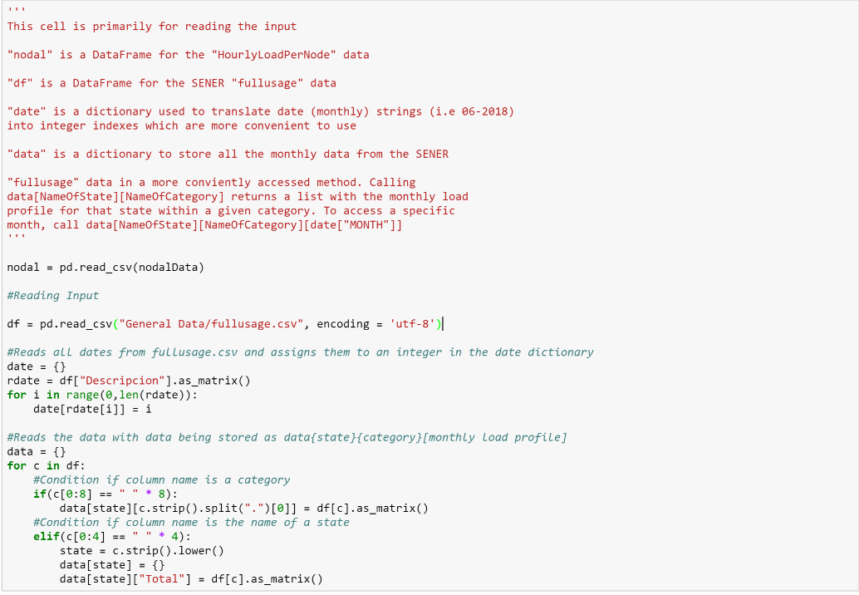The first thing done by the model is to store the fullusage data in a conveniently accessed manner. To do so, the data is stored in an array where data[NameOfState][NameOfCategory] returns a list with the monthly load profile for that state within a given category. Additionally, a dictionary named date maps the string of each month to an index used in data. The code to run this process is pasted below:

Next, to calculate the projected monthly load curve, aggregated between all sectors, the HourlyLoadPerNode data was utilized, by simply finding the sum over all of the projected hourly load curves. The method is trivial and can be found under the name calcTotal in the node class. Splitting this curve into that of each sector involves multiplying each value by the percent of the aggregated monthly load the sector required in a state containing the energy provider. The function to find this percentage is named calcPerOfSec and can also be found in the node class.

Now, we have obtained the monthly load profile by regional provider by sector, we have to disaggregate it by matching the shape of each month’s hourly load profile to that of a region we have complete data on. The region of choice was the Southern California Edison data because of its exhaustiveness. The data was processed by taking the percentage of each hourly load over the respective monthly load. An example of this processed data can be found in the Industrial Data folder under the name of MedIndPros.csv.

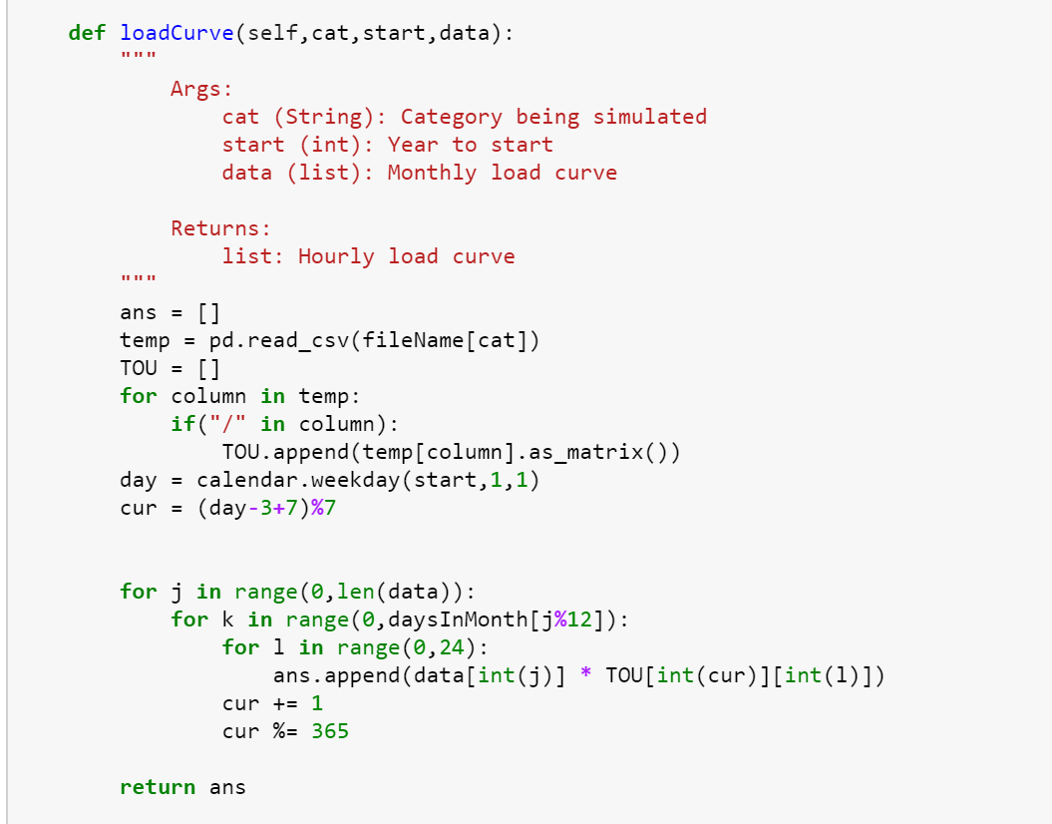To generate the load curve of each region, the monthly load was multiplied by each of these time-of-use percentages and appended to an array. The categories applied to this process are Medium Industrial, Large Industrial, and Agricultural because these are the least likely to experience weather dependent loads and therefore the sectors most likely to hold true to the assumptions. The residential (weather dependent) data for each region was calculated by taking the difference of the aggregated hourly load and the sum of the generated data points for that hour. This process is done through the generate method, calling loadcurve to get obtain the hourly load for each category and the aggregate function to find the sum of the generated load curves. The load curve function is displayed below. Note that it accounts for the difference of the starting day of the week for each year to maintain consistency.

The generated data is then printed to the “Generated” directory as a csv file if the write parameter in the generate function is set to True, which by default it is not.

# Policies

# BiblioGraphy

NorthWest GS Primary Usage: *http://www.northwesternenergy.com/for-suppliers/customer-load-profiles/gs-primary-customer-profile*

Mexico Electricity Usage by Technology by Sector: *https://datos.gob.mx/busca/dataset/electricidad*

PG&E Static Load Profile: *https://www.pge.com/nots/rates/2000_static.shtml*

SCE Static Load Profile: *https://www.sce.com/wps/portal/home/regulatory/load-profiles/2016%20static%20load%20profiles/!ut/p/b1/jZDLbsIwEEV_JSyyJJ4kNNDurKYKSaFAH6rxpjLUcVKZTOS4ROLrMaiqVKmv2c3cczV3hnDCCG_EvlbC1tgIfep58lLkKQ2zUZRn4yIFukzH6dN9Eo5uQwesHQA_FIW__MU_FkRmfj1XhLfCVsO6KZEwjeJ12Bosay07wiIIE6-zLvXWO0nep_RM-HnDZQY302IBefa4iiGPV3D3QGkMkHwAv5zgMiqNm_M71rTZxBMXxshSGmmCd-PGlbVtd-WDD33fBwpRaRlscefDd5YKO0vYV5K0O3aYTeHtQu9nlA4GR4F1RsU!/dl4/d5/L2dBISEvZ0FBIS9nQSEh/*

BGE Historical Load Data: *https://supplier.bge.com/electric/load/profiles.asp*

# Appendix

## Appendix A – Assumptions

* The distribution of the load among different technologies is the same in a region as it is in a state containing the region
* The weekly distribution of the load remains constant through the season and between similar regions
* The shape of the monthly load profile stays consistent in a region throughout multiple years
* Any of the electricity not used by Medium Industrial, Large Industrial, or Agricultural, is Residential

## Appendix B – Validating load Curve Generation Process

To validate the similarity of the hourly load curve within each hour of the month for each respective month, the same process applied into Mexico’s load curve was applied to the PG&E 2000 data which we had the complete data for. The average error in the calculated load for each hour was 10.59% and the standard deviation was 9%.

The code and visualization for this can be found in the Region Comparison notebook in the “Data Exploration” Directory.

## Appendix C – HVAC Curve Generation Through MLP Neural Networks